Practical Assignment 3

STEP 1: Install Snort (On Snort VM)
Documentation used to install snort: https://upcloud.com/resources/tutorials/install-snort-ubuntu/
Check Snort version: snort -V

STEP 2 : Find Network Interface
Note your interface (example: eth0 or ens33) : ip a

STEP 3 : Edit Snort Configuration
Open: sudo nano /etc/snort/rules/snort.conf
Find: ipvar HOME_NET any
Change to your network (example): ipvar HOME_NET 192.168.147.0/24
Save and exit.

STEP 4 : Add Rules in local.rules
Open: sudo nano /etc/snort/rules/local.rules
Paste ALL the following rules:

Task 1 : ICMP Request Alert
alert icmp any any -> $HOME_NET any (msg:"ICMP Ping Detected"; sid:1000001; rev:1;)

Task 2 : SYN Scan Detection (Nmap)
alert tcp any any -> $HOME_NET any (flags:S; msg:"SYN Scan Detected"; sid:1000002; rev:1;)

Task 3 : HTTP GET Request Detection
alert tcp any any -> $HOME_NET 80 (msg:"HTTP GET Request Detected"; content:"GET"; http_method; sid:1000003; rev:1;)

Task 4 : Directory Traversal Detection
alert tcp any any -> $HOME_NET 80 (msg:"Directory Traversal Attempt"; content:"../"; http_uri; sid:1000004; rev:1;)

Task 5 : SQL Injection Detection
alert tcp any any -> $HOME_NET 80 (msg:"SQL Injection Attempt"; content:"' OR 1=1"; nocase; http_uri; sid:1000005; rev:1;)

Save and exit.

alert icmp any any -> $HOME_NET any (msg:"ICMP Ping Detected"; sid:1000001; rev:1;)
alert tcp any any -> $HOME_NET any (flags:S; msg:"SYN Scan Detected"; sid:1000002; rev:1;)
alert tcp any any -> $HOME_NET 80 (msg:"HTTP GET Request Detected"; content:"GET"; sid:1000003; rev:1;)
alert tcp any any -> $HOME_NET 80 (msg:"Directory Traversal Attempt"; content:"../"; http_uri; sid:1000004; rev:1;)
alert tcp any any -> $HOME_NET 80 (msg:"SQL Injection Attempt"; content:"' OR 1=1"; nocase; http_uri; sid:1000005; rev:1;)
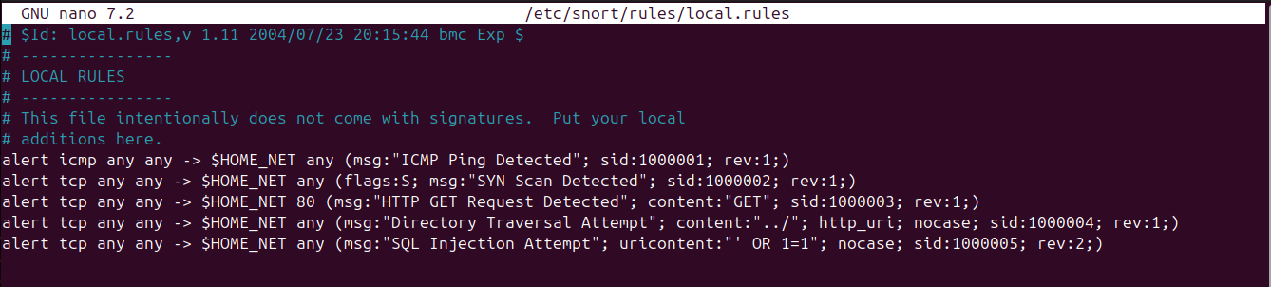

STEP 5 : Start Snort in IDS Mode
sudo snort -A console -i ens33 -u snort -g snort -c /etc/snort/snort.conf
(Replace ens33 with your interface). Snort will now monitor traffic.

GENERATE ATTACKS (From Attacker Machine)
Task 1 : Generate ICMP Alert
ICMP ping checks whether a host is reachable on the network.

Snort triggered an alert when it saw ICMP traffic directed to the HOME_NET.

ping <IP_of_Snort_VM>
You should see: ICMP Ping Detected
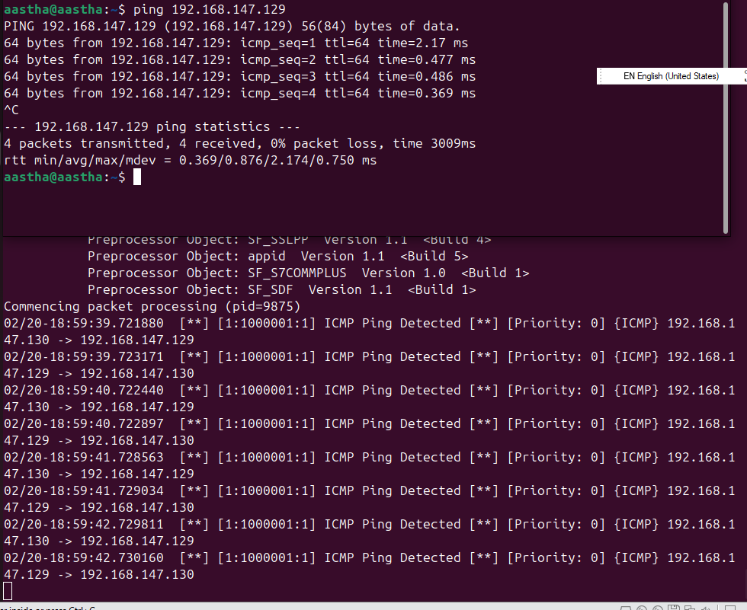
Task 2 : Generate SYN Scan Alert
A SYN scan sends TCP SYN packets to discover open ports without completing the handshake.
Snort detected TCP packets with only the SYN flag set.
Using Nmap: nmap -sS <IP_of_Snort_VM>
You should see SYN Scan Detected
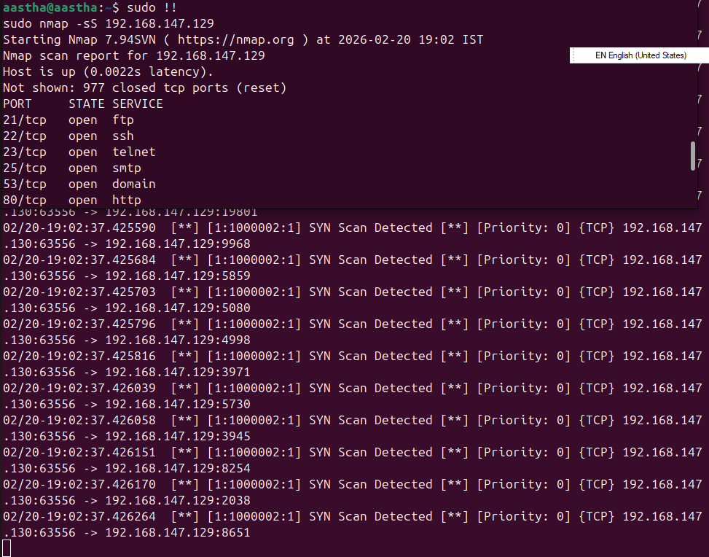
Task 3 : Generate HTTP GET Alert
An HTTP GET request retrieves data from a web server.
Snort inspected HTTP traffic and triggered when it matched the GET method.
If Apache is running on Snort VM: sudo apt install apache2 -y
From attacker: curl http://192.168.147.130
You should see HTTP GET Request Detected
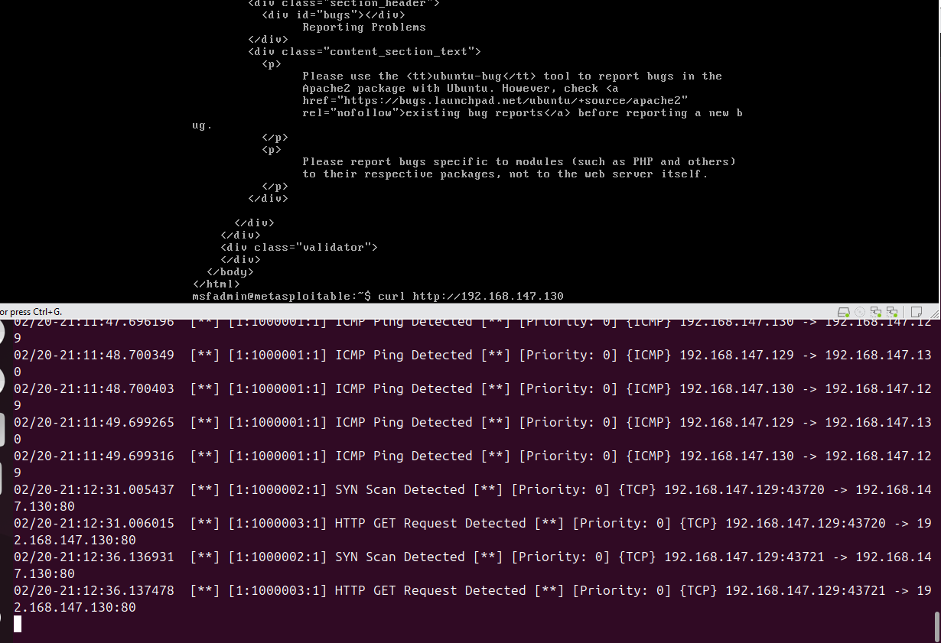
Task 4 : Generate Directory Traversal
Directory traversal attempts to access restricted files using ../ in the URL.
Snort matched ../ inside the HTTP URI.
curl http://192.168.147.130/../../../etc/passwd
curl http://192.168.147.130/dvwa/vulnerabilities/fi/?page=../../../include.php
You should see Directory Traversal Attempt
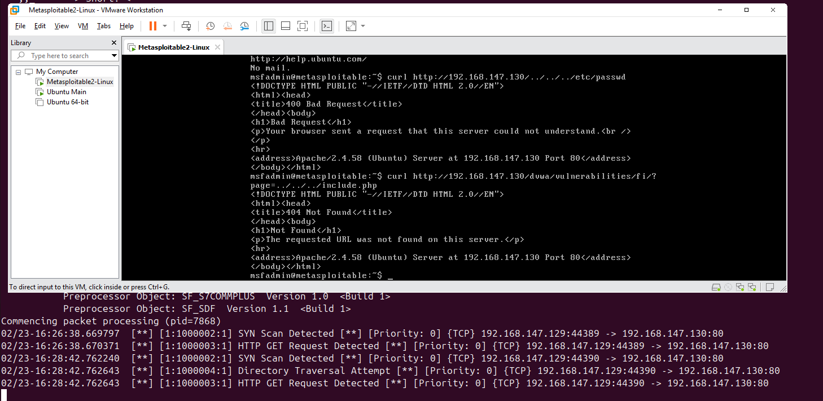
Task 5 : Generate SQL Injection Attempt
SQL injection manipulates database queries to bypass authentication or extract data.
Snort matched the pattern ' OR 1=1 inside the HTTP URI.
curl "http://192.168.147.130/index.php?id=1' OR 1=1"
curl "http://192.168.147.130/index.php?id=1%27%20OR%201=1"
You should see SQL Injection Attempt
